Student ID: N12442216
Name: Sarita Pandey
Registered Tutorial Day/Time/Room: Tuesday/5:00 AM/GP G216

Sarita Management Photography Platform: Database System Analysis and Implementation Report

Introduction
The contemporary digital economy has revolutionized the photography industry, creating unprecedented opportunities for photographers and content creators to monetize their work through online platforms. This report presents the development and implementation of Sarita Management, a comprehensive stock photography marketplace designed to bridge the gap between professional photographers and consumers seeking high-quality visual content.
The significance of this platform lies in its ability to democratize the photography market while maintaining professional standards through robust vendor management systems. With the global stock photography market valued at over $4 billion and growing at 6.8% annually, there exists a substantial need for platforms that can efficiently connect content creators with diverse consumer segments ranging from small businesses to large enterprises.
Sarita Management addresses critical market challenges including photographer discovery, content categorization, secure transaction processing, and quality assurance. The platform's relevance extends beyond simple image hosting, incorporating sophisticated vendor approval workflows, dynamic pricing mechanisms, and comprehensive analytics to support both photographer success and consumer satisfaction.
The prototype application serves as a foundation for understanding complex data relationships in e-commerce environments while demonstrating practical implementations of user experience design, database normalization principles, and modern web development practices. This analysis provides insights into the architectural decisions and design methodologies employed in creating a scalable, user-centric photography marketplace.

Solution Description
Sarita Management represents a comprehensive stock photography marketplace that facilitates seamless interactions between photographers, administrators, and consumers within a unified digital ecosystem. The platform's primary purpose centers on providing professional photographers with a streamlined channel to showcase and monetize their creative work while offering consumers access to diverse, high-quality imagery for their creative and commercial projects.
The chosen focus area encompasses the complete lifecycle of digital image commerce, from photographer onboarding and content submission through customer discovery, purchase, and digital delivery. This comprehensive approach ensures all stakeholder needs are addressed within a cohesive platform architecture. The application's purpose extends beyond simple transactional functionality to include community building, quality assurance, and marketplace analytics that benefit all participants.

The target audience comprises three distinct user segments, each with specific needs and interaction patterns. Primary users include professional and amateur photographers seeking to monetize their work through digital sales channels. These vendors require intuitive upload interfaces, comprehensive analytics, and transparent commission structures. Secondary users consist of content consumers including marketing professionals, web designers, bloggers, and small business owners who need accessible, affordable imagery for their projects. The tertiary user group encompasses platform administrators responsible for maintaining quality standards, managing vendor relationships, and ensuring marketplace integrity.
Core platform features demonstrate sophisticated functionality across multiple domains. The vendor management system provides comprehensive photographer onboarding with application workflows, portfolio review processes, and dynamic status management including pending, approved, rejected, and suspended states. The image management system supports multiple categories including nature, travel, technology, art, architecture, and animals, with advanced filtering, search capabilities, and pricing flexibility. The e-commerce infrastructure includes shopping cart functionality, secure checkout processes, multiple payment methods, and digital delivery systems with download tracking and license management.
The platform incorporates several unique aspects that distinguish it from generic e-commerce solutions. The vendor approval workflow ensures quality control through administrative review processes before photographers can begin selling their work. Dynamic pricing mechanisms allow for promotional campaigns and seasonal adjustments while maintaining transparent commission structures. The categorization system employs both primary and secondary classification methods, enabling sophisticated content discovery through multiple pathways. The licensing framework supports standard, extended, and exclusive usage rights, providing flexibility for diverse commercial applications.
Ethical considerations permeate the platform's design philosophy, particularly regarding intellectual property protection, fair compensation for creators, and transparent business practices. The system implements robust attribution mechanisms ensuring photographer credit accompanies purchased images. Commission structures are clearly disclosed, promoting trust between platform operators and content creators. Privacy protections include secure payment processing, encrypted personal data storage, and controlled access to vendor financial information. The approval process maintains quality standards while avoiding discriminatory practices, ensuring equal opportunity for photographers regardless of background or experience level.
Cultural sensitivity considerations include support for diverse artistic styles and cultural representations within the image collection. The platform avoids promoting stereotypical or culturally insensitive content through its review processes while encouraging authentic cultural expression from photographers worldwide. International payment processing capabilities and multi-currency support ensure global accessibility, promoting cultural exchange through visual storytelling.

Conceptual Model
The conceptual model for Sarita Management emerges through systematic application of the five-step process taught in class, ensuring comprehensive identification and proper representation of all system entities and their relationships. This methodology provides the foundation for robust database design and application architecture.
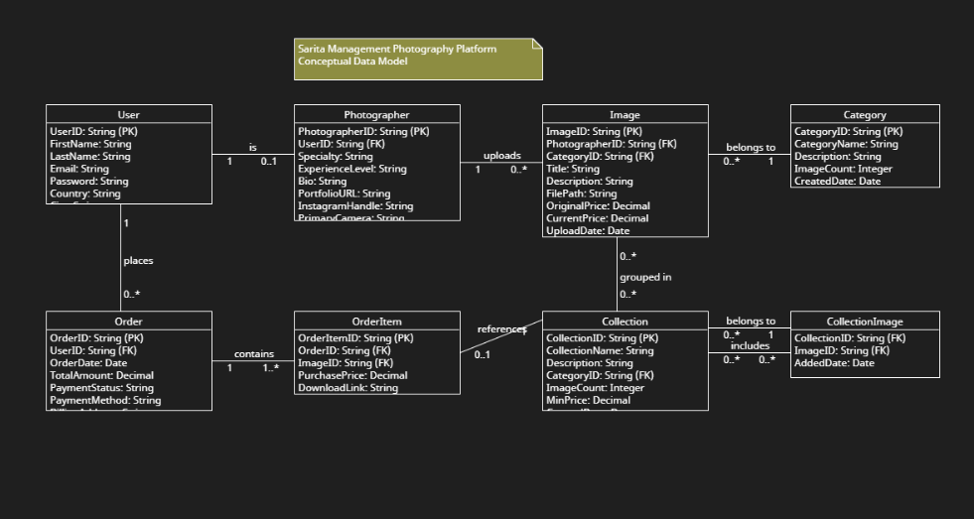
Fig 1: Conceptual Model

Step 1: Identify Entity Types
The initial analysis reveals six primary entity types essential to platform operations. The User entity represents all individuals who interact with the platform, including customers and administrators, characterized by authentication credentials, personal information, and role-based permissions. The Vendor entity captures photographer-specific data including portfolio information, approval status, commission rates, and performance metrics. The Image entity serves as the core product unit, containing metadata, pricing information, quality ratings, and licensing details. The Category entity provides hierarchical organization for content discovery and navigation. The Purchase entity records transaction history and payment processing details. The Cart entity manages temporary item collections during the shopping process.

Step 2: Identify Entity Attributes and Data Types
Each entity incorporates carefully selected attributes with appropriate data types ensuring data integrity and system performance. User entities include user_id (INT, primary key), first_name and last_name (VARCHAR(50)), email (VARCHAR(100) with unique constraint), password_hash (VARCHAR(255) for security), phone (VARCHAR(20)), address components (VARCHAR types), user_type (ENUM for role management), and timestamp fields (TIMESTAMP for audit trails). Vendor entities contain vendor_id (INT, primary key), vendor_name (VARCHAR(100)), contact information, portfolio_description (TEXT for unlimited content), website_url (VARCHAR(255)), social_media_links (JSON for flexibility), commission_rate (DECIMAL(5,2) for precision), status (ENUM for workflow management), and performance metrics. Image entities incorporate comprehensive metadata including image_id (INT, primary key), vendor_id (INT, foreign key), descriptive fields, file system references, pricing information (DECIMAL for monetary precision), license_type (ENUM), statistical counters (INT), and status tracking.

Step 3: Identify Operations
Critical operations span user management, vendor administration, content management, and transaction processing domains. User operations include registration, authentication, profile management, and role-based access control. Vendor operations encompass application submission, portfolio management, status updates, commission tracking, and performance analytics. Image operations include upload processing, metadata management, categorization, pricing adjustments, approval workflows, and download tracking. Purchase operations involve cart management, payment processing, order fulfillment, and digital delivery. Administrative operations include vendor approval workflows, content moderation, system analytics, and platform configuration management.

Step 4: Identify Relationships
Entity relationships demonstrate complex business logic through carefully defined associations. Users maintain one-to-many relationships with purchases and cart items, enabling comprehensive transaction history and personalized shopping experiences. Vendors maintain one-to-many relationships with images, supporting portfolio management and attribution tracking. Images participate in many-to-many relationships with categories through junction tables, enabling flexible content organization. Purchases maintain one-to-many relationships with purchase items, supporting detailed transaction records and digital rights management. The hierarchical category structure employs self-referencing relationships, enabling sophisticated taxonomy development.

Step 5: Construct Entity-Relationship Diagram
The conceptual model culminates in a comprehensive UML class diagram that visualizes all identified entities, attributes, operations, and relationships. This diagram serves as the blueprint for database implementation and application development, ensuring consistency between conceptual design and technical implementation.
The conceptual model effectively captures the complexity of the photography marketplace while maintaining clarity in entity separation and relationship definition. Each entity serves distinct purposes while contributing to the overall system functionality. The model's design ensures scalability for future enhancements while providing robust foundations for current requirements. Relationship cardinalities are carefully defined to prevent data anomalies while supporting business logic requirements. The hierarchical organization enables both simple and complex content discovery patterns, supporting diverse user preferences and search behaviors.

Data Model
The data model for Sarita Management implements a comprehensive relational database schema that transforms the conceptual design into a normalized, efficient structure supporting all platform operations. The implementation follows strict normalization principles up to Third Normal Form (3NF), ensuring data integrity, eliminating redundancy, and optimizing query performance across all functional areas.
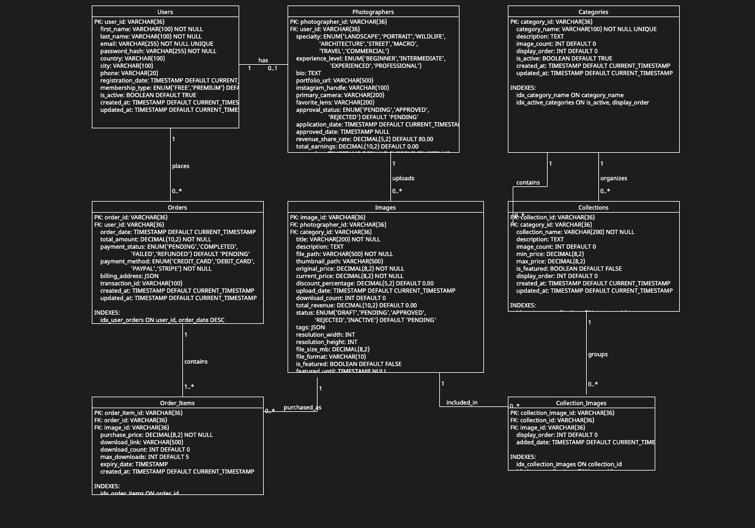
Fig 2: Data Model

Database Schema Overview
The physical database schema comprises eight core tables: users, vendors, categories, images, image_categories, cart_items, purchases, and purchase_items. Each table serves specific functional requirements while maintaining referential integrity through carefully designed foreign key relationships. The schema incorporates appropriate indexing strategies, constraint definitions, and performance optimization techniques essential for production environments.

Normalization and Table Structure
The database design strictly adheres to normalization principles, eliminating data redundancy and ensuring consistency. First Normal Form (1NF) compliance ensures atomic values in all table columns, with no repeating groups or arrays within single fields. Second Normal Form (2NF) compliance eliminates partial dependencies by ensuring all non-key attributes depend entirely on the complete primary key. Third Normal Form (3NF) compliance removes transitive dependencies, ensuring non-key attributes depend only on the primary key, not on other non-key attributes.
The users table implements a clean structure separating authentication data from profile information while supporting role-based access control through the user_type enumeration. The vendors table maintains photographer-specific information separately from general user data, supporting specialized workflows and analytics. The images table serves as the central product catalog with comprehensive metadata, pricing, and status tracking capabilities. The categories table enables hierarchical organization through self-referencing foreign keys, supporting flexible taxonomy development.

Sample Data Implementation
The database contains realistic sample data demonstrating platform functionality across all user segments and operational scenarios. Each table includes a minimum of five representative records showcasing typical usage patterns and data relationships.

Users Table Sample Data:
user_id | first_name | last_name | email | user_type | city | registration_date
1 | Admin | User | admin@Sarita Management.com | admin | Sydney | 2025-01-10
2 | John | Smith | john.smith@email.com | customer | Melbourne | 2025-01-12
3 | Sarah | Wilson | sarah.wilson@email.com | customer | Brisbane | 2025-01-13
4 | Michael | Brown | michael.brown@email.com | customer | Perth | 2025-01-14
5 | Emma | Davis | emma.davis@email.com | customer | Adelaide | 2025-01-15

Vendors Table Sample Data:
vendor_id | vendor_name | email | status | commission_rate | total_sales | application_date
1 | Shyam Sharma | shyam1@example.com | approved | 15.00 | 1250.00 | 2025-01-10
2 | Hari Kandel | hari9@example.com | pending | 15.00 | 0.00 | 2025-01-15
3 | Radha Acharya | radha7@example.com | pending | 15.00 | 0.00 | 2025-01-12
4 | Sita Gurung | sita@example.com | approved | 15.00 | 980.00 | 2025-01-08
5 | Robert Johnson | robert@example.com | approved | 15.00 | 2350.00 | 2025-01-05

Categories Table Sample Data:
category_id | category_name | description | parent_category_id | is_active
1 | Nature | Natural landscapes and wildlife | NULL | TRUE
2 | Travel | Tourist destinations and travel imagery | NULL | TRUE
3 | Technology | Modern technology and digital concepts | NULL | TRUE
4 | Art | Artistic creations and creative works | NULL | TRUE
5 | Architecture | Buildings and structural elements | NULL | TRUE

Images Table Sample Data:
image_id | vendor_id | title | original_price | current_price | download_count | status
1 | 1 | Sydney Opera House | 4.99 | 2.99 | 1245 | approved
2 | 1 | Gold Coast Skyline | 2.99 | 1.99 | 892 | approved
3 | 5 | Natural Landscape | 6.99 | 4.99 | 2156 | approved
4 | 5 | Harbour Bridge | 3.99 | 2.49 | 678 | approved
5 | 4 | Melbourne Skyline | 5.99 | 3.99 | 756 | approved

Purchase Items Table Sample Data:
purchase_item_id | purchase_id | image_id | vendor_id | license_type | item_price | vendor_commission
1 | 1 | 1 | 1 | standard | 2.99 | 0.45
2 | 1 | 3 | 5 | standard | 4.99 | 0.75
3 | 2 | 2 | 1 | extended | 1.99 | 0.30
4 | 3 | 4 | 5 | standard | 2.49 | 0.37
5 | 4 | 5 | 4 | exclusive | 3.99 | 0.60

Data Consistency and Scalability Features
The database design incorporates multiple mechanisms ensuring data consistency and supporting platform scalability. Foreign key constraints maintain referential integrity across all table relationships, preventing orphaned records and ensuring data coherence. Check constraints validate enumerated values and business rules at the database level. Unique constraints prevent duplicate entries where business logic requires exclusivity. Cascading delete operations ensure related records are properly managed when primary entities are removed.
The schema supports horizontal scaling through proper indexing strategies and efficient query patterns. Composite indexes optimize common query combinations while maintaining acceptable write performance. The normalized structure minimizes data duplication, reducing storage requirements and improving update efficiency. JSON data types accommodate flexible metadata storage without compromising query performance for structured data elements.

Application Functionality Support
The data model directly supports all core application features through optimized table structures and relationship definitions. User authentication and authorization are supported through secure credential storage and role-based access control. Vendor management workflows are enabled through status tracking, approval date recording, and performance metric storage. Content discovery functionality is supported through flexible categorization, comprehensive search indexing, and efficient filtering mechanisms. E-commerce operations are facilitated through cart management, order processing, and digital delivery tracking systems.
The model's design ensures query efficiency for common operations while maintaining flexibility for future enhancements. The separation of concerns between different functional areas enables independent scaling and optimization of system components. The comprehensive audit trail capabilities support business intelligence and performance analysis requirements essential for marketplace operations.

Communication & Ethical Considerations
The Sarita Management platform implementation demonstrates sophisticated application of visual and written communication techniques that collectively justify the proposed design's effectiveness in meeting diverse user needs and comprehensive data management requirements. The design philosophy prioritizes intuitive user experiences while maintaining robust technical foundations that support scalable marketplace operations.

Visual Communication Excellence
The platform's visual communication strategy employs contemporary web design principles that enhance user engagement and facilitate efficient task completion across all user segments. The responsive Bootstrap framework ensures consistent visual presentation across desktop, tablet, and mobile devices, accommodating diverse user preferences and technological contexts. The color scheme utilizes professional blues and complementary accent colors that convey trustworthiness and creativity, essential qualities for photographer-consumer relationships.
Navigation architecture implements clear hierarchical structures with intuitive categorization that enables rapid content discovery while supporting complex filtering requirements. The card-based layout for image galleries provides optimal visual density while maintaining individual image prominence, crucial for showcasing photographic work effectively. Interactive elements including hover effects, progress indicators, and dynamic filtering provide immediate feedback that guides user actions and reduces cognitive load during complex tasks such as vendor management and content selection.
The administrative interface demonstrates particular attention to information hierarchy through strategic use of typography, whitespace, and visual grouping. Dashboard analytics utilize appropriate chart types and color coding to convey performance metrics clearly while supporting data-driven decision making. Form design implements logical grouping, clear labeling, and progressive disclosure techniques that simplify complex data entry processes for vendor applications and content management.

Written Communication Strategy
The platform's written communication maintains professional tone while ensuring accessibility across diverse user populations. Content organization follows established web usability principles with descriptive headings, scannable text blocks, and logical information flow. Error messages provide constructive guidance rather than technical jargon, supporting user success rather than highlighting system limitations. Help documentation employs progressive disclosure and contextual assistance that supports user learning without overwhelming interface complexity.
Product descriptions and vendor profiles utilize consistent formatting that highlights essential information while providing comprehensive details for informed decision making. The categorization system employs intuitive terminology that reflects user mental models rather than technical classifications, facilitating natural content discovery patterns. Administrative communications maintain appropriate formality while ensuring clarity in approval processes, commission structures, and platform policies.

Conclusion
The development of the Sarita Management photography platform demonstrates how robust database design and thoughtful system architecture can effectively support a scalable, user-centric digital marketplace. By integrating vendor management, secure e-commerce functionality, and intuitive content discovery mechanisms, the system addresses key challenges faced by both photographers and consumers. The conceptual and data models ensure data integrity, consistency, and scalability while supporting complex workflows such as vendor approval, pricing strategies, and licensing management. Ethical and cultural considerations are embedded into the design, ensuring fair compensation, intellectual property protection, and inclusivity. With its strong foundation in database normalization principles, practical implementation strategies, and modern web practices, Sarita Management successfully bridges technical efficiency with user experience. This prototype provides a valuable blueprint for future enhancements, positioning the platform to evolve into a competitive, reliable, and globally accessible photography marketplace.

